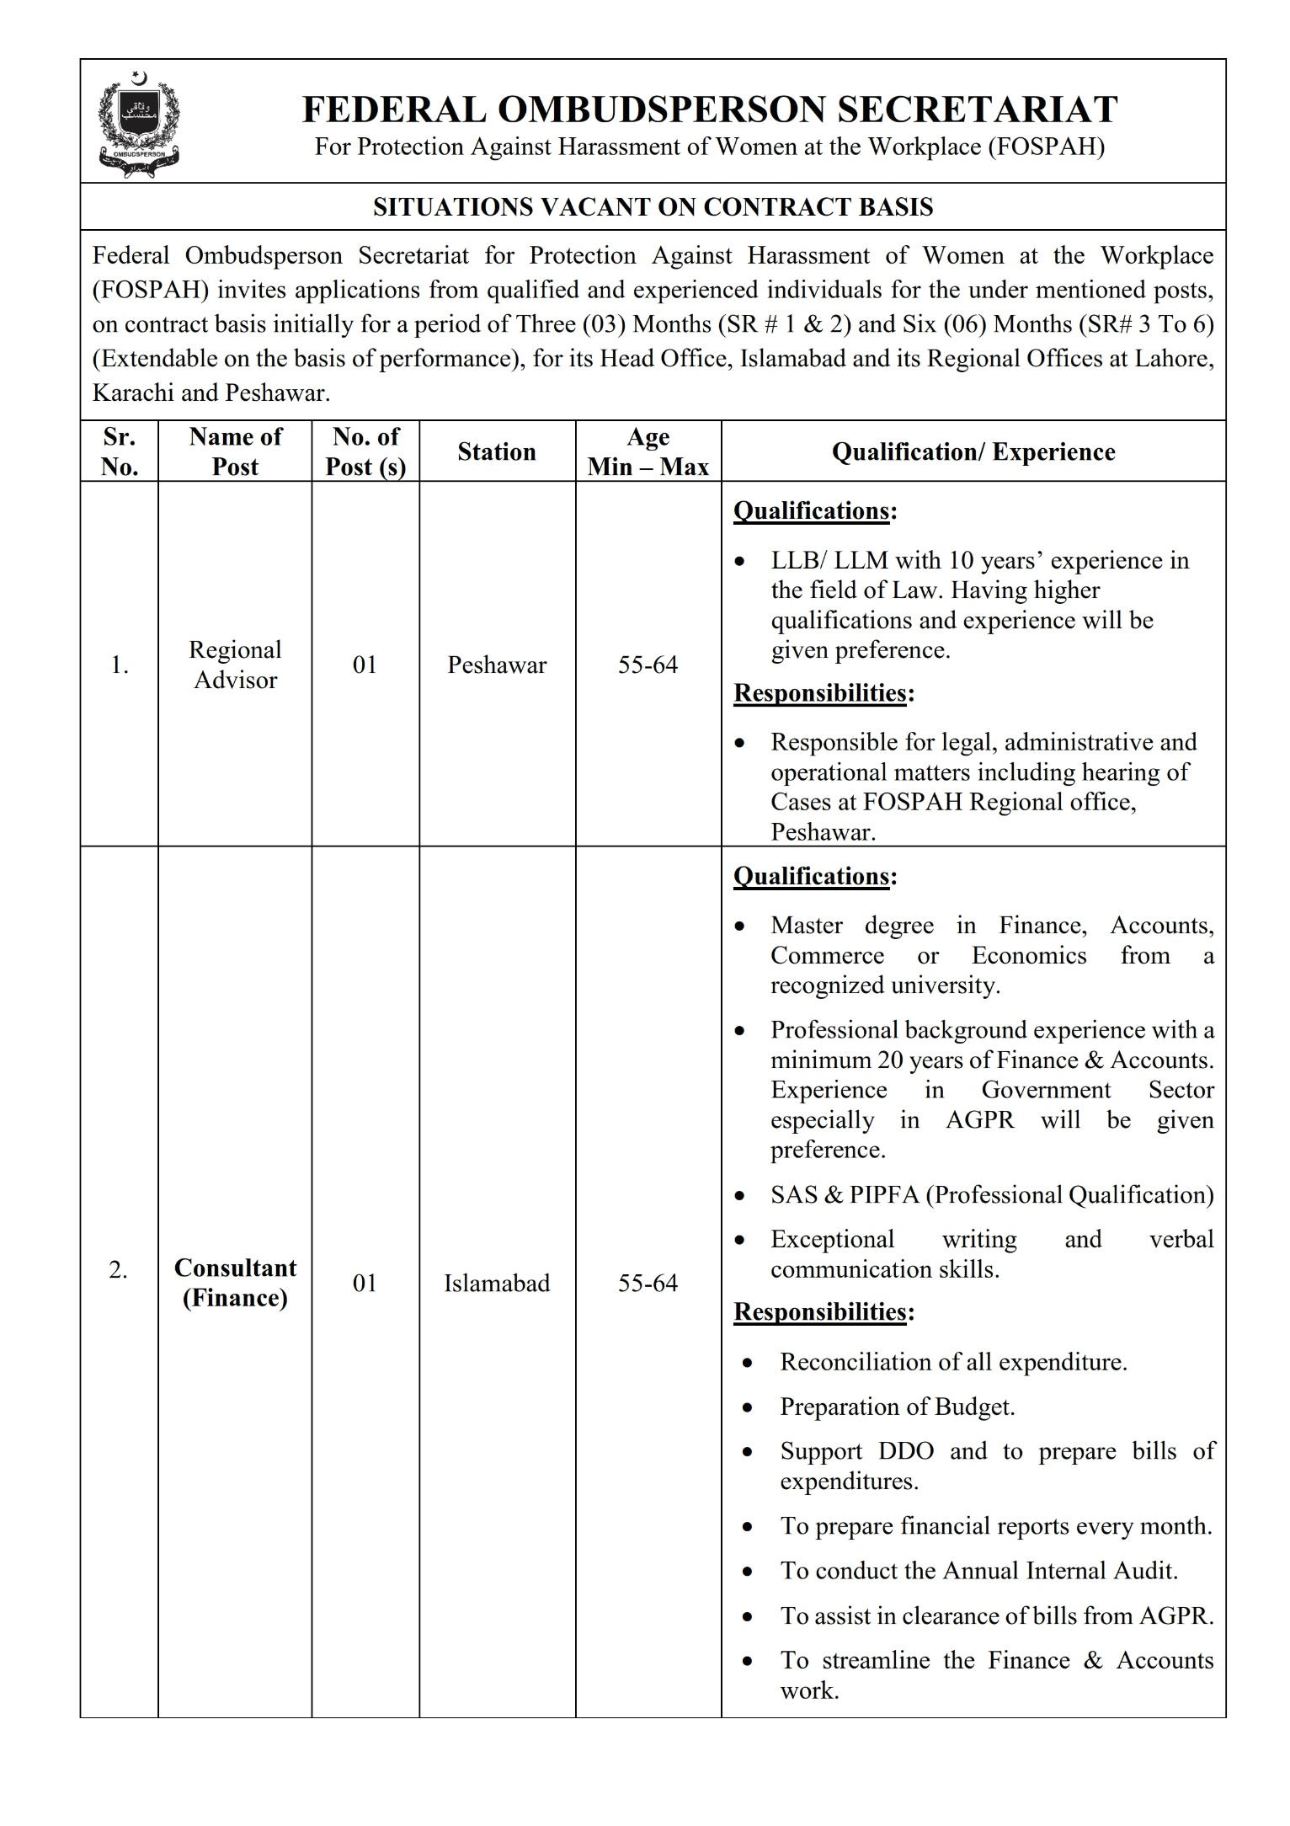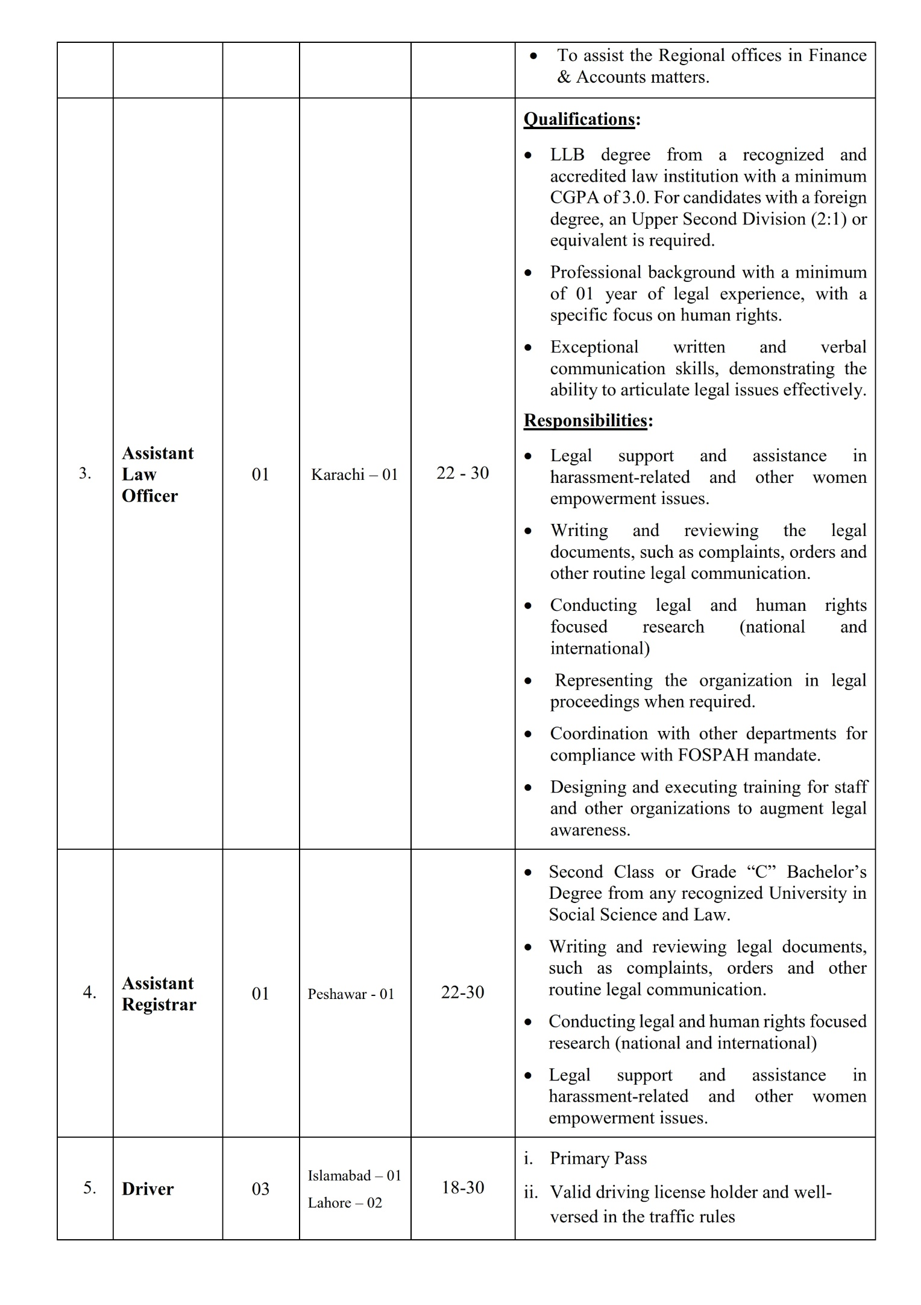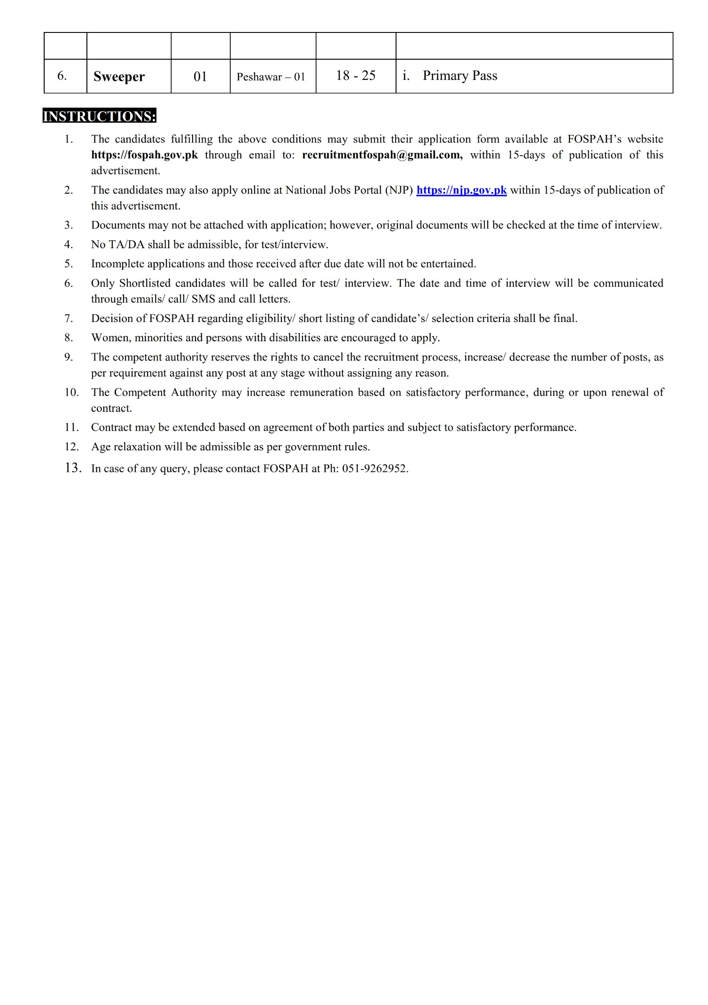

FEDERAL OMBUDSPERSON SECRETARIAT
For Protection Against Harassment of Women at the Workplace (FOSPAH)
APPLICATION FORM
Application No___________
(For Official use only)
- Name of the Post Applied for _______________________________________________
- Name of the Applicant (in block letters) _______________________________________
- Father’s Name (in block letters)______________________________________________
- Address (a) current Postal Address____________________________________________
________________________________________________________________________
(b) Permanent Address_____________________________________________________
________________________________________________________________________
(c) Mobile Number ____________________(d) Email Address_____________________
- Domicile Province and District________________________Gender_________________
- Date of Birth (as per secondary school certificates) ______________________________
- Age (as on closing date of advertisement) ______________________________________
- Religion______________________________CNIC Number_______________________
- Disability, if any (Type of disability)
- Qualification:
Degree | Passing Year | Division/Grade | Board/ University/ Institute | Major Subjects

- Experience:
Employer Name | Position Title | Field of Work | From | To

- I hereby undertake that the information provided by me is correct and any information found incorrect at later stage will lead to cancellation of candidature for the above-mentioned post. I am also aware of the fact that incomplete filing up of the form will result disqualification of my candidature with no subsequent claim whatsoever.

Date:________________ Signature of the Applicant: ________________
Note:
Interested candidates if want to apply directly may send their application forms till 28th February 2024 through email to recruitmentfospah@gmail.com or can also apply on https://njp.gov.pk

